1. Download the instructions (.docx), input data (.tsv), and code (.usql) for the Labs.
   1. Lab-Setup-Guide.docx
   2. LabForModuleTwoThree.docx
   3. LabForModuleFourFive.docx
   4. Paper_authors.tsv
   5. Paper_venue.tsv
   6. LabForModuleTwoThree.usql
   7. LabForModuleFourFive.usql
2. Create a free Azure Account

<https://azure.microsoft.com/en-us/get-started>

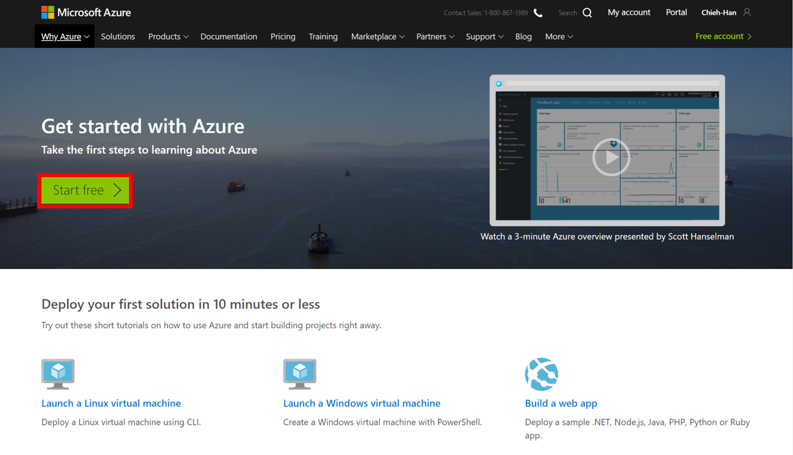

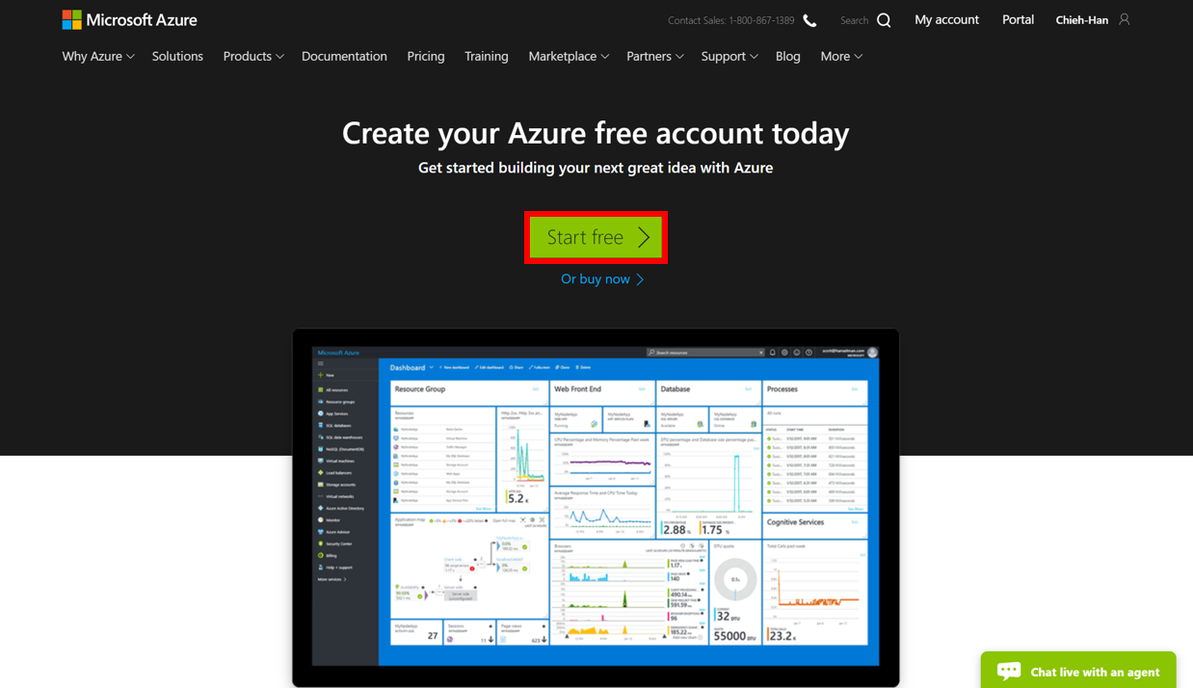

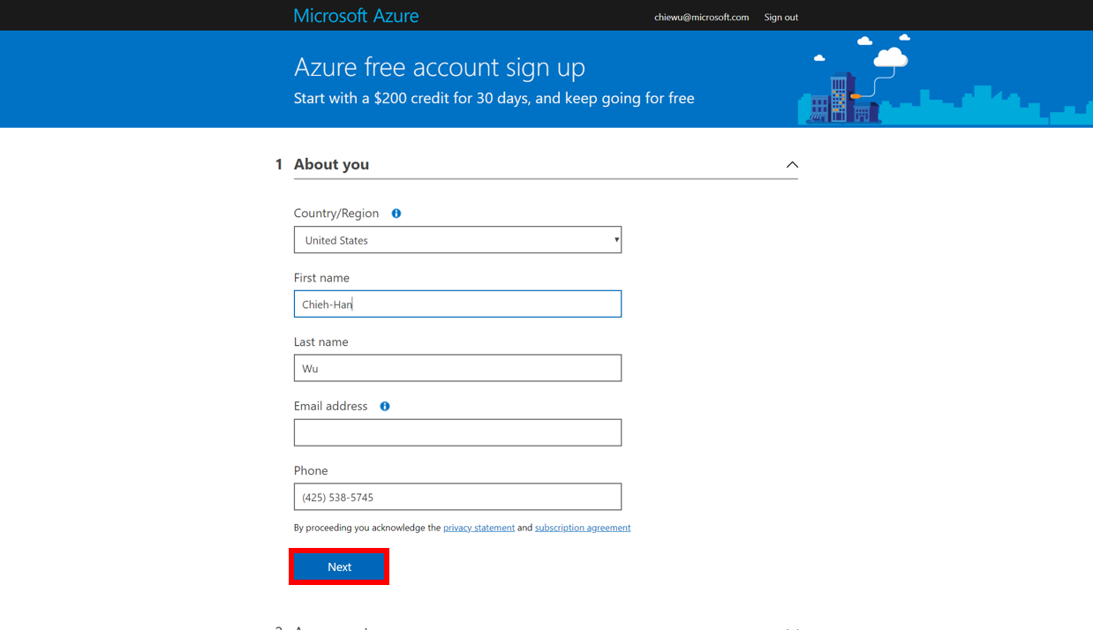

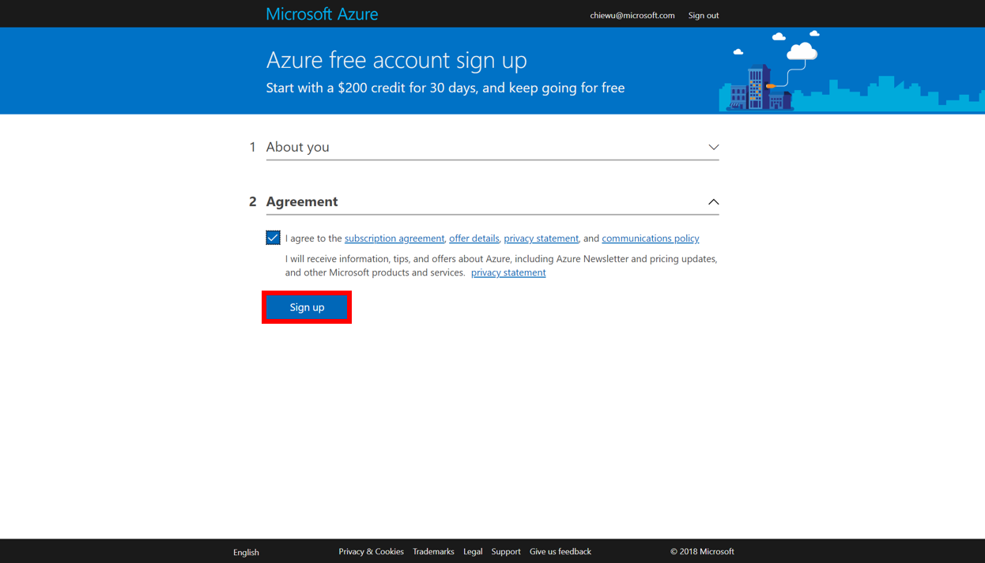

1. Create a Data Lake Analytics and a Data Lake Store Account
   1. Sign on to the Azure portal.

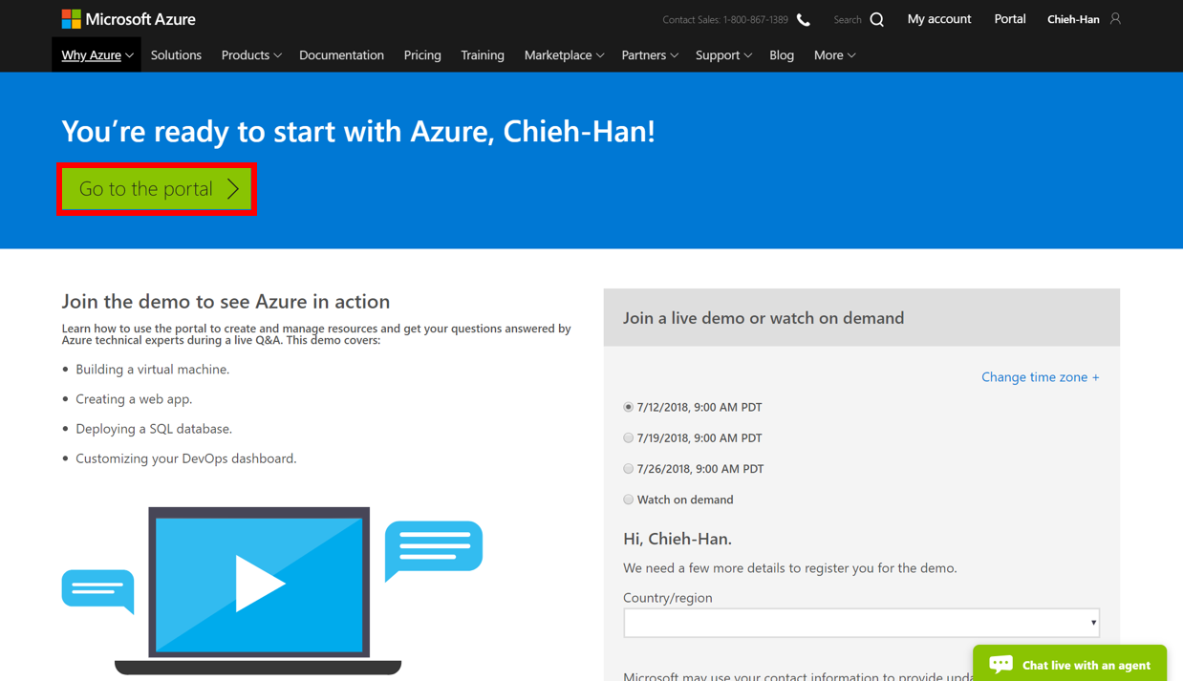

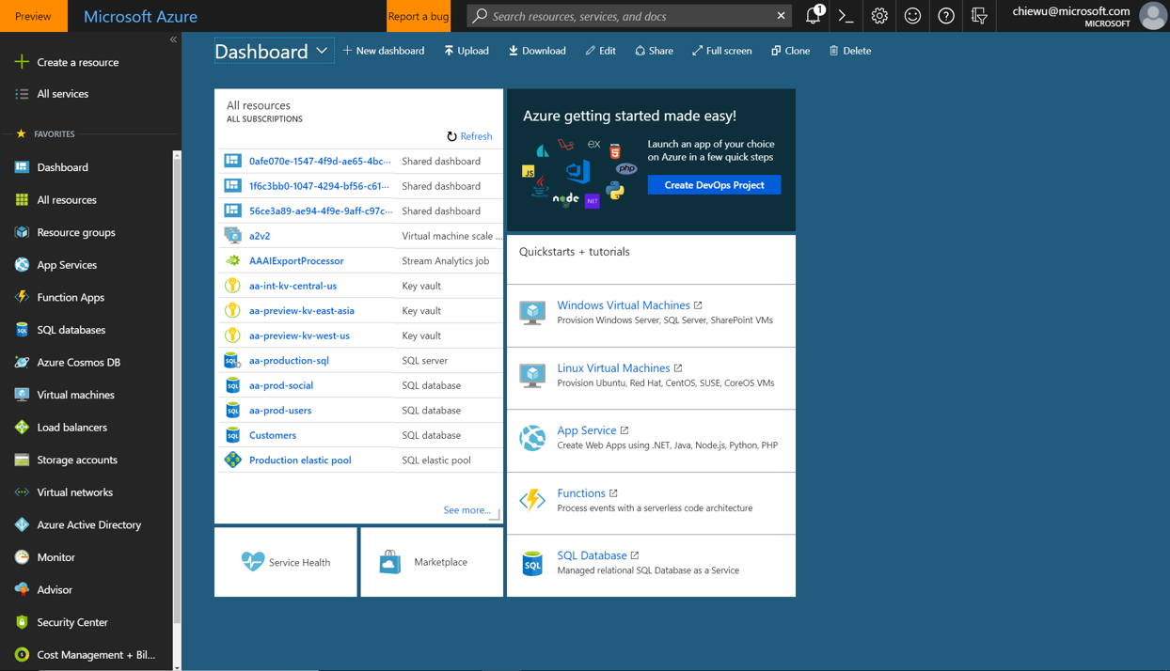

* 1. Click **Create a resource** > **Analytics** > **Data Lake Analytics**.

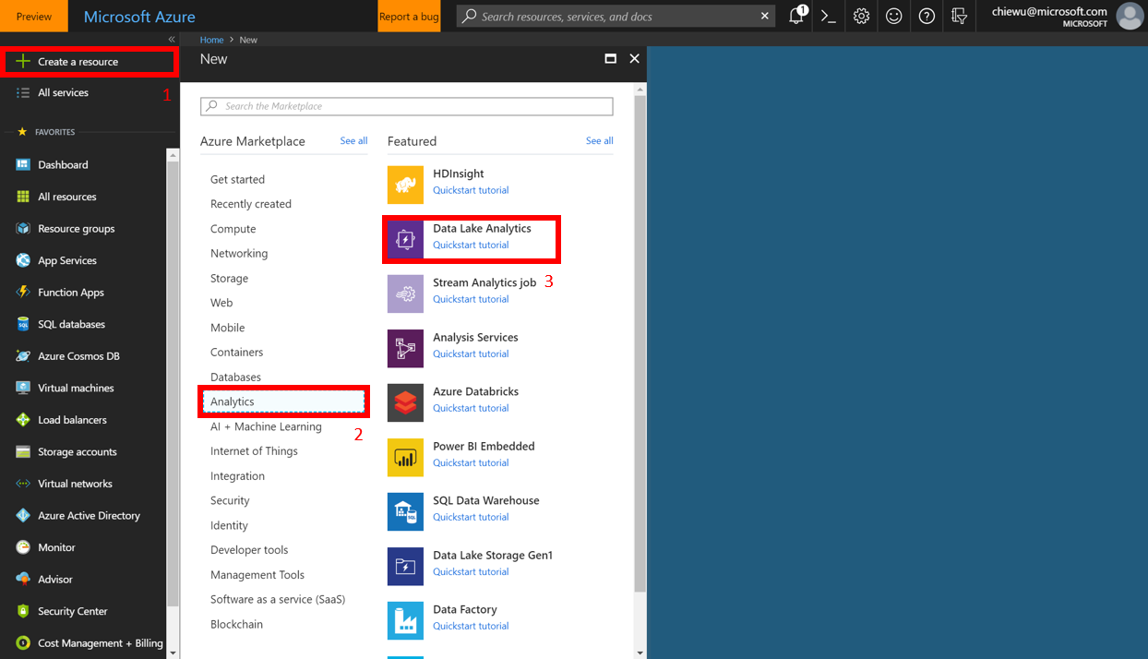

* 1. Select values for the following items:
     + Name: Name your Data Lake Analytics account (Only lower case letters and numbers allowed).
     + Subscription: Choose the Azure subscription used for the Analytics account.
     + Resource Group: Select an existing Azure Resource Group or create a new one.
     + Location: Select an Azure data center for the Data Lake Analytics account.
     + Data Lake Store: Follow the instruction to create a new Data Lake Store account, or select an existing one.
     + Optionally, select a pricing tier for your Data Lake Analytics account.

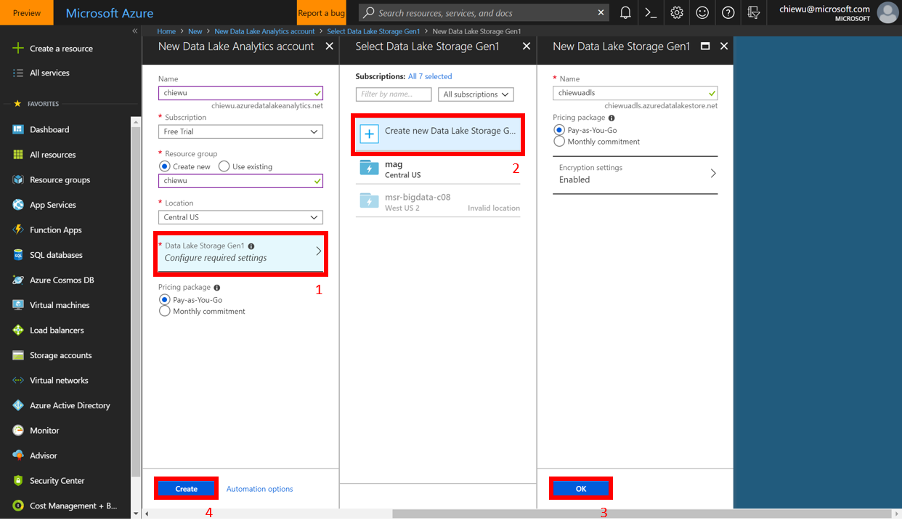

* 1. View your Data Lake Analytics and Data Lake Store Account in **All resources**.

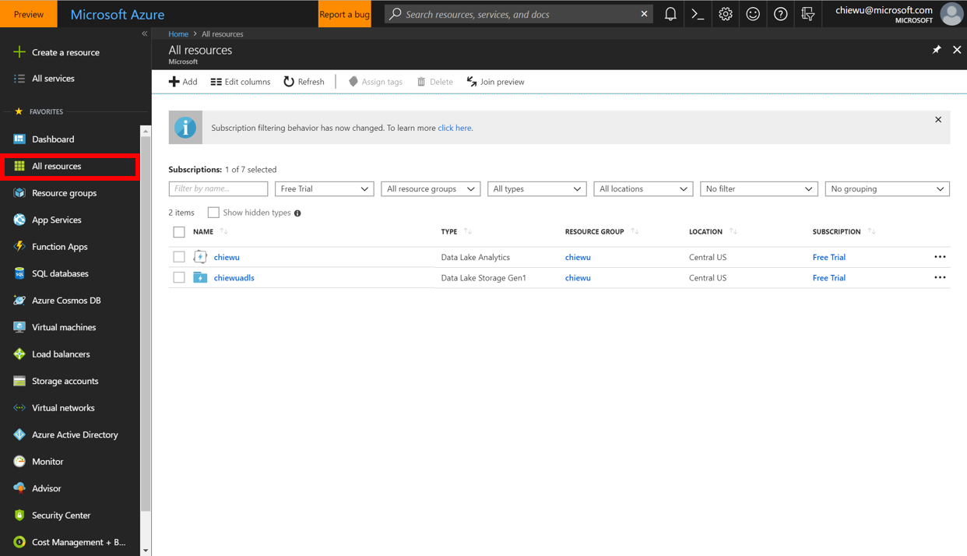

1. Upload the Lab data to Azure Data Lake Store account
   1. Go to Azure Data Lake Analytics account and click **Data explorer**.

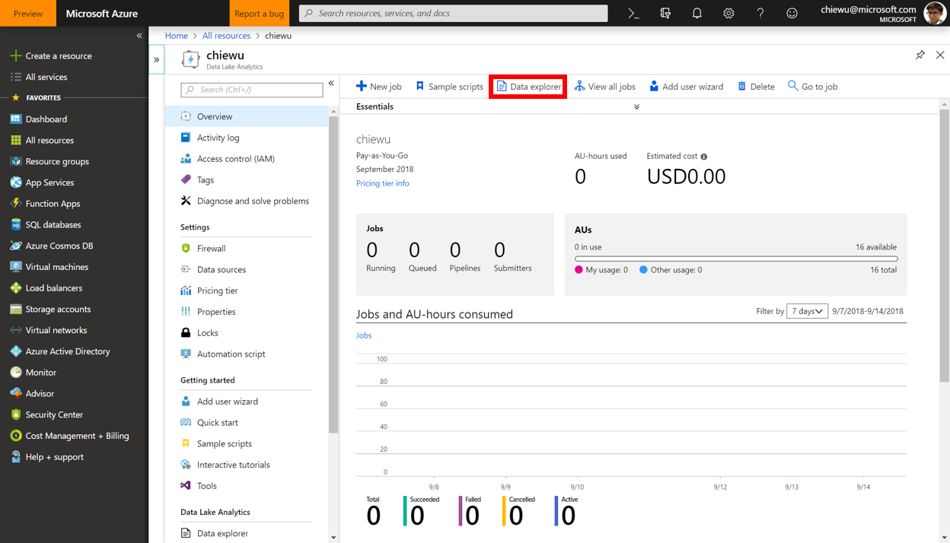

* 1. Click **New folder** to create a new folder under Azure Data Lake Store account.

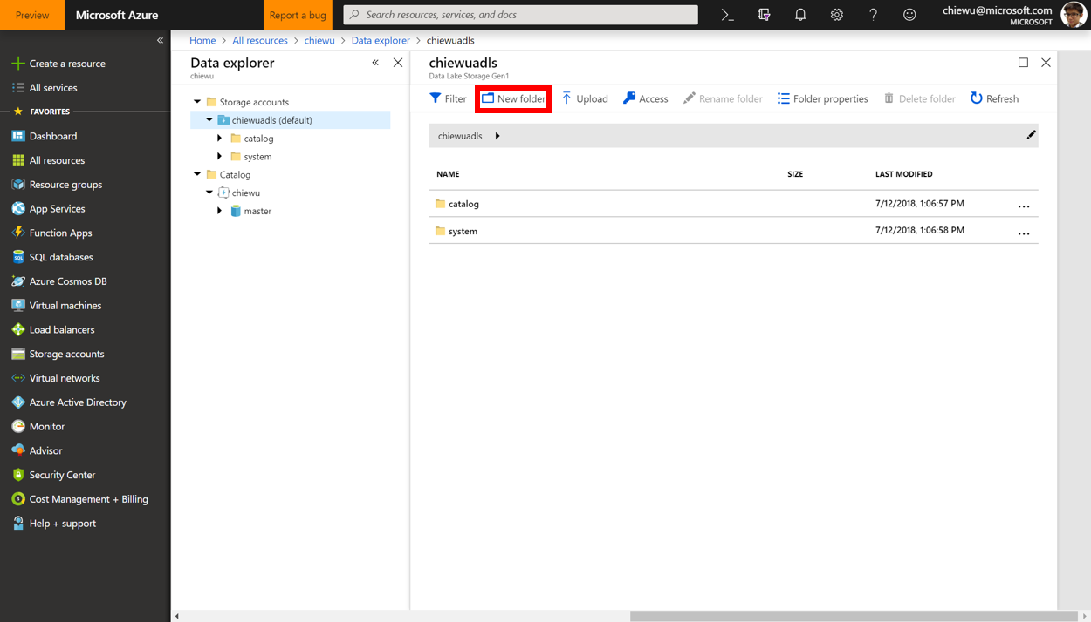

* 1. Use “**course-kg**” as the folder name and click **OK**.

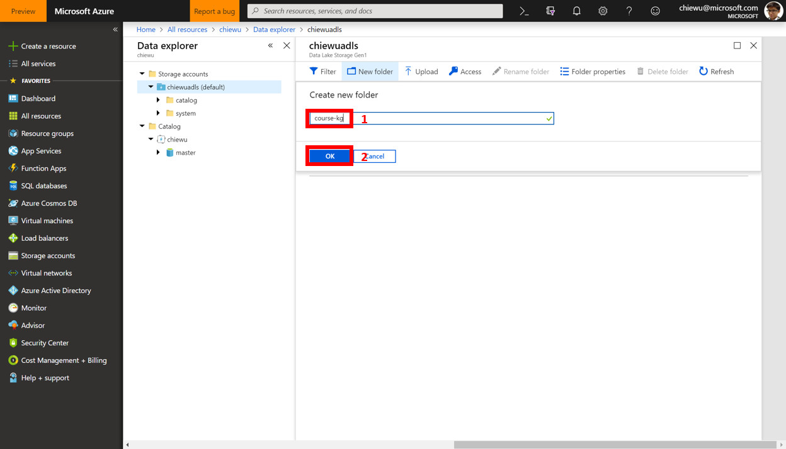

* 1. Click **course-kg** to go into this folder.

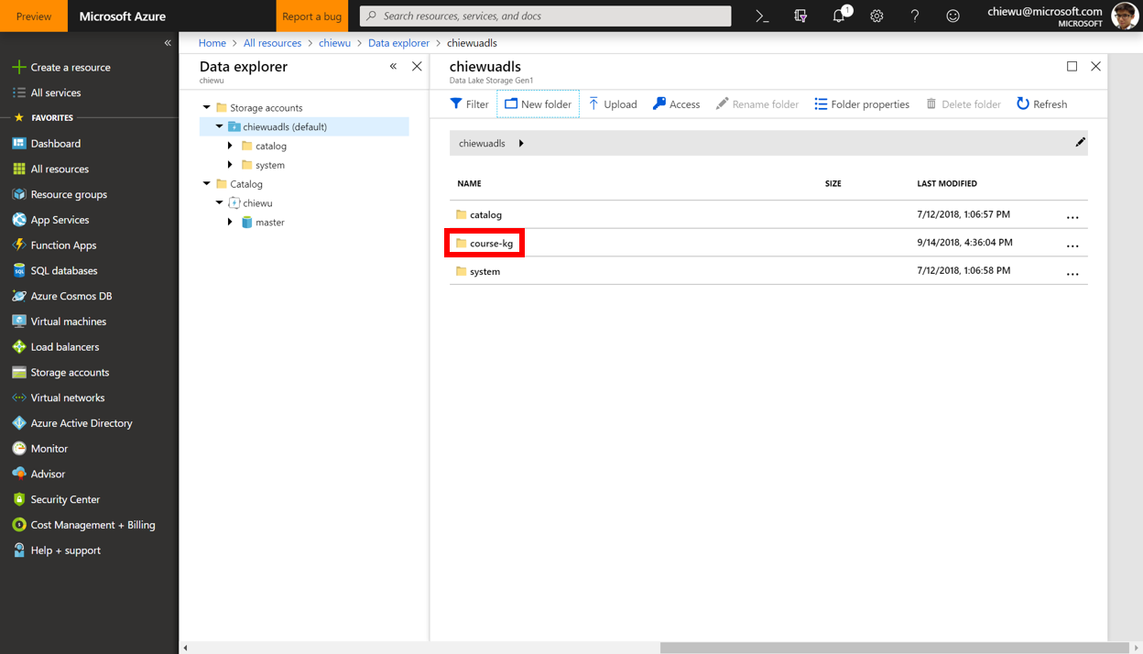

* 1. Create a new folder “**input**” under “course-kg” folder.

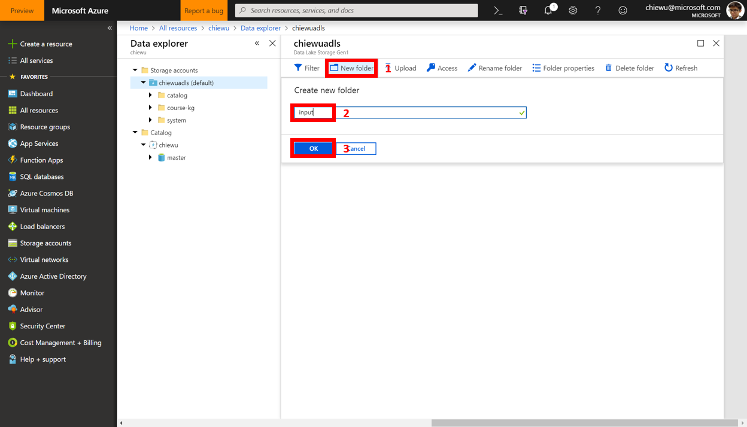

* 1. Click **input** to go into this folder.

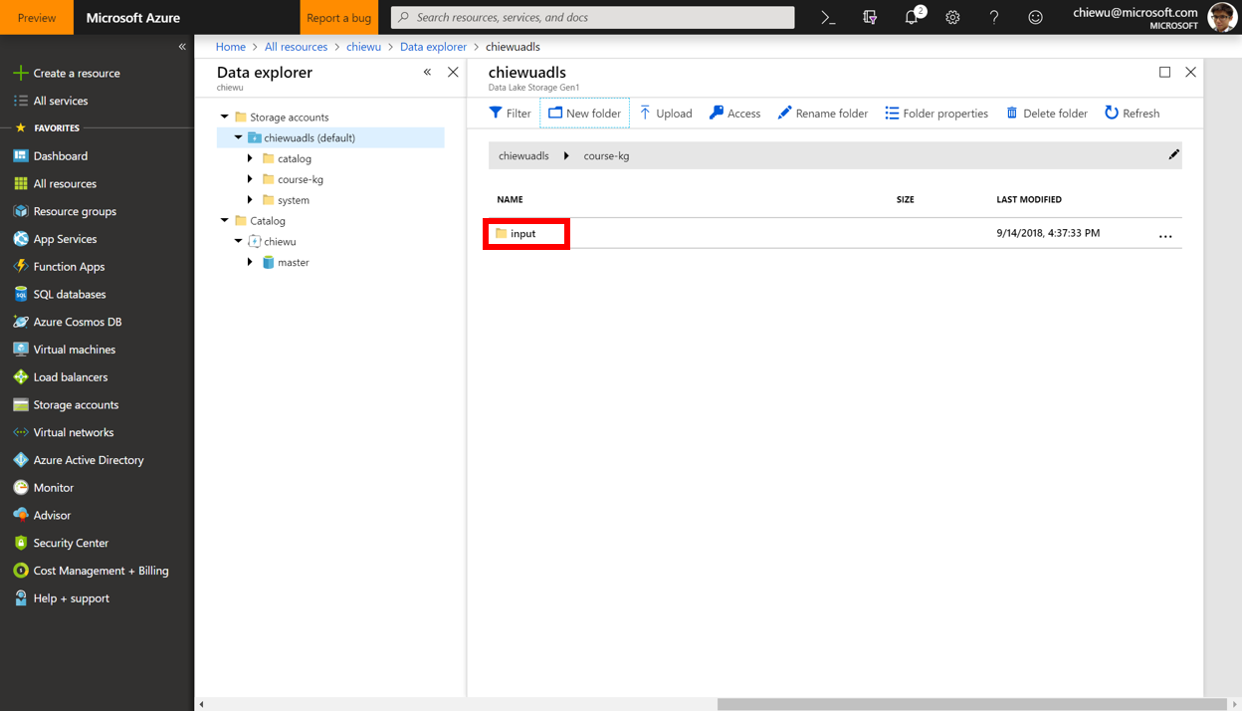

* 1. Click **Upload**.

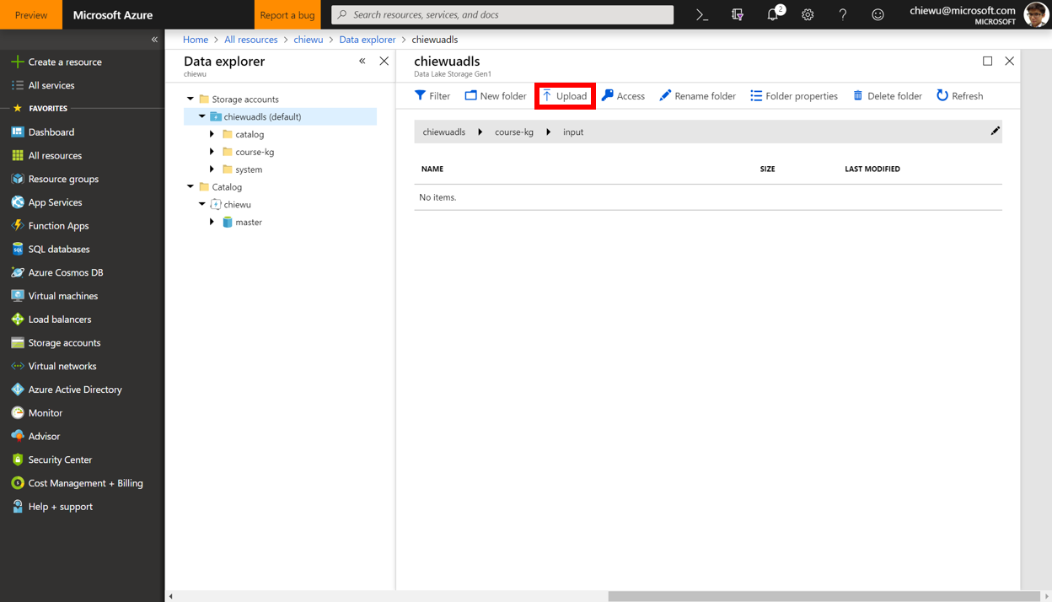

* 1. Upload “**Paper_authors.tsv**” to the “course-kg/input” folder.

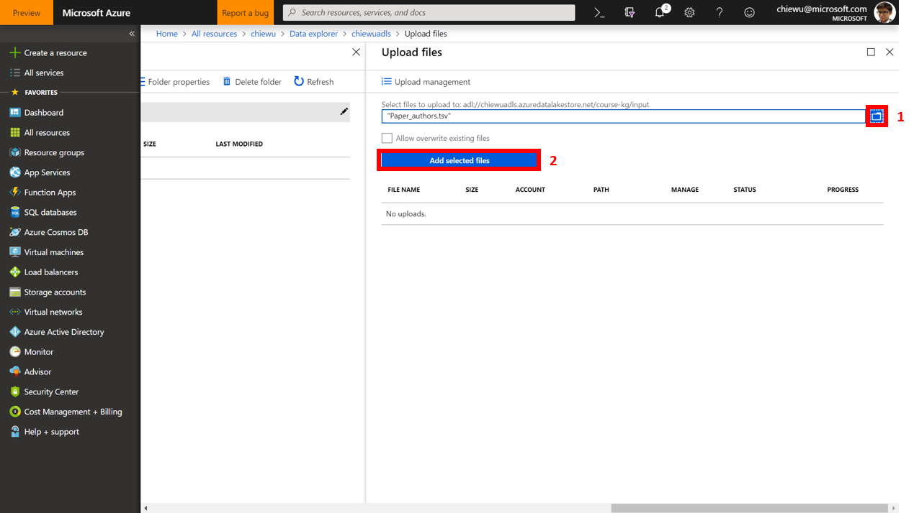

* 1. Upload “**Paper_venue.tsv**” to the “course-kg/input” folder.

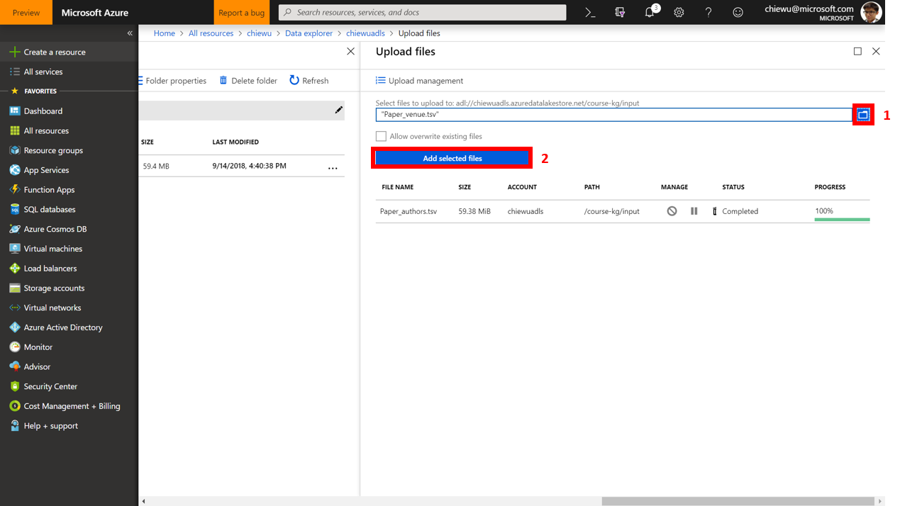

* 1. View uploaded files under “course-kg/input” folder.

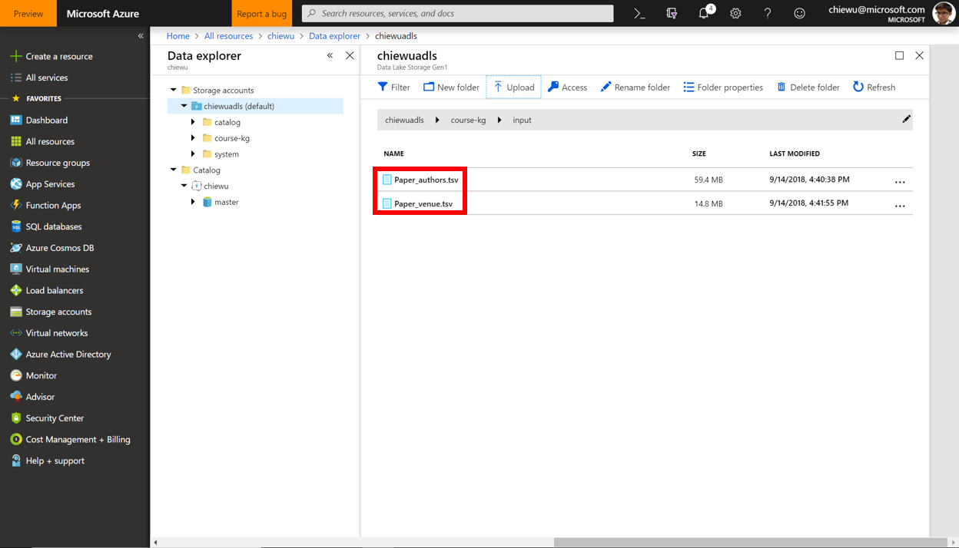

1. Upload the Lab data to Azure Data Lake Store account
   1. Go to Azure Data Lake Analytics account and click **New job** on the top menu.

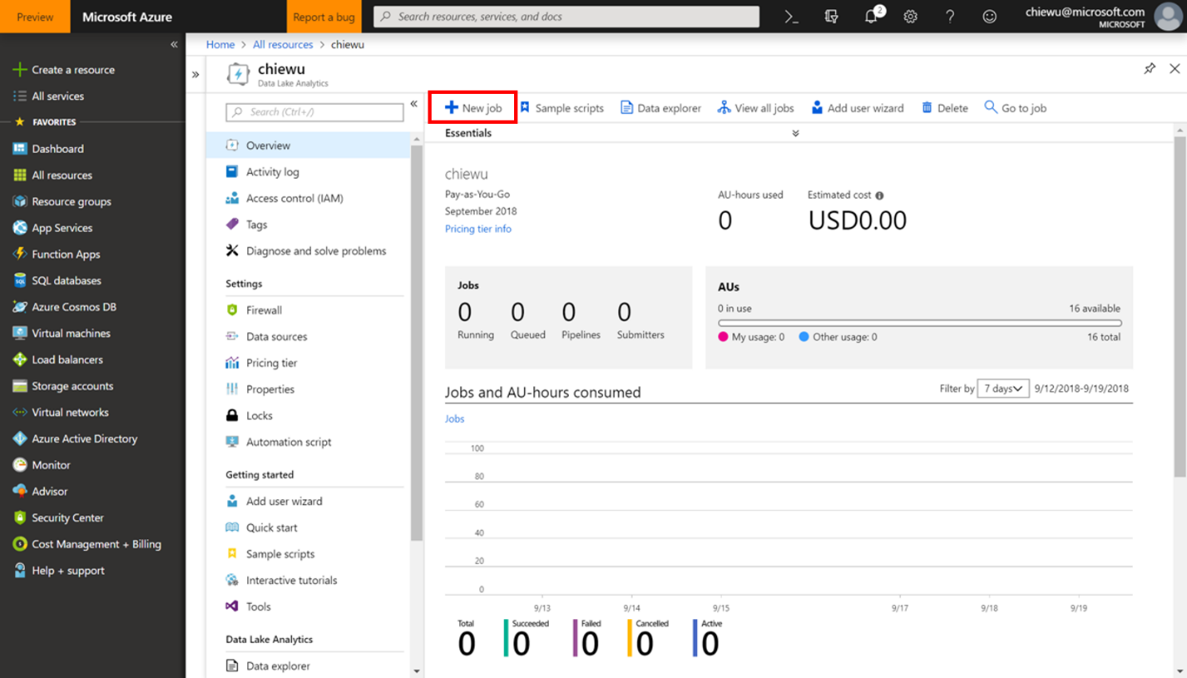

* 1. Click **Open file** to open the Lab script written in U-SQL, for example, the first lab’s script “LabForModuleTwoThree.usql”.

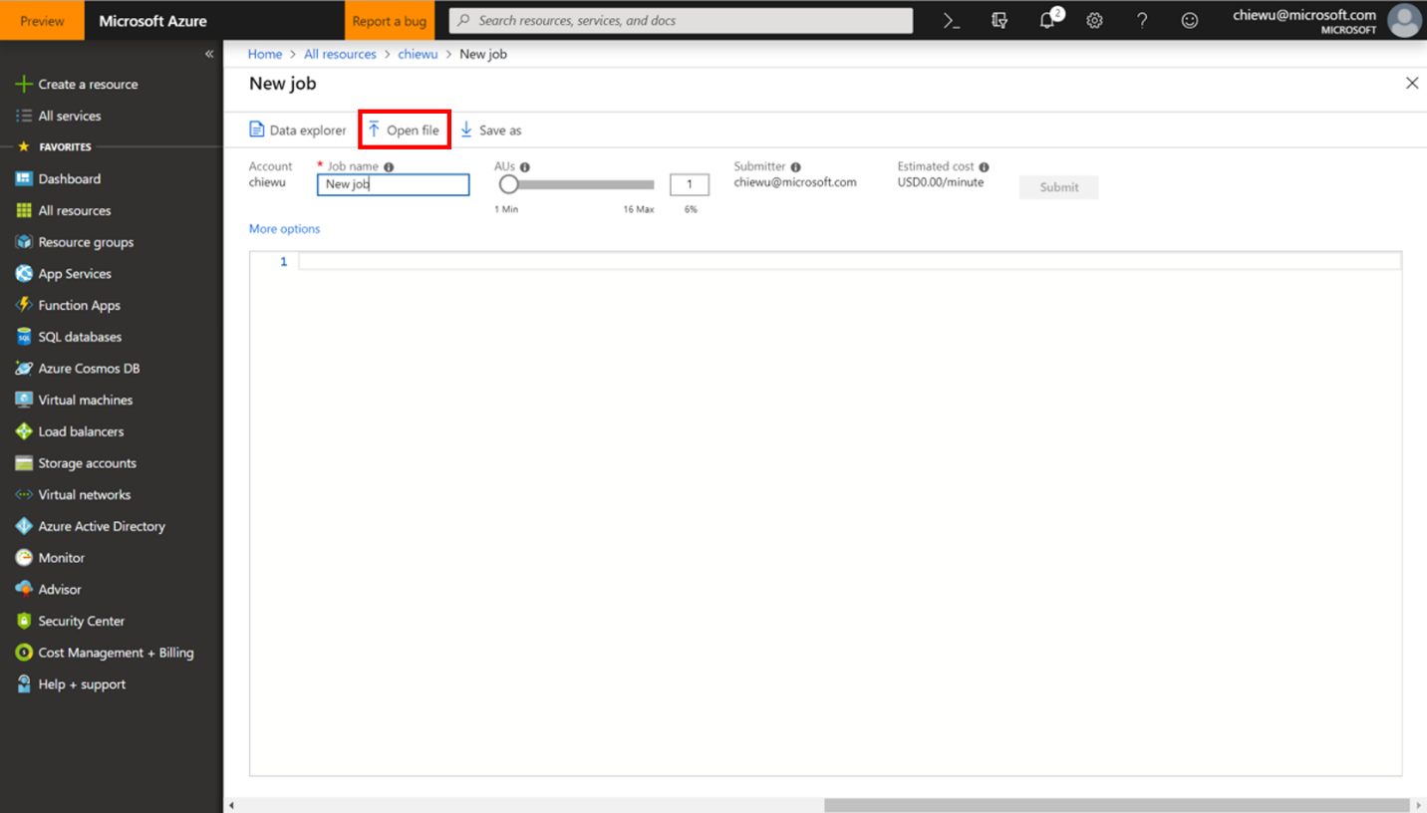

* 1. Fill in the missing line of code for each question (see details in Lab instructions).

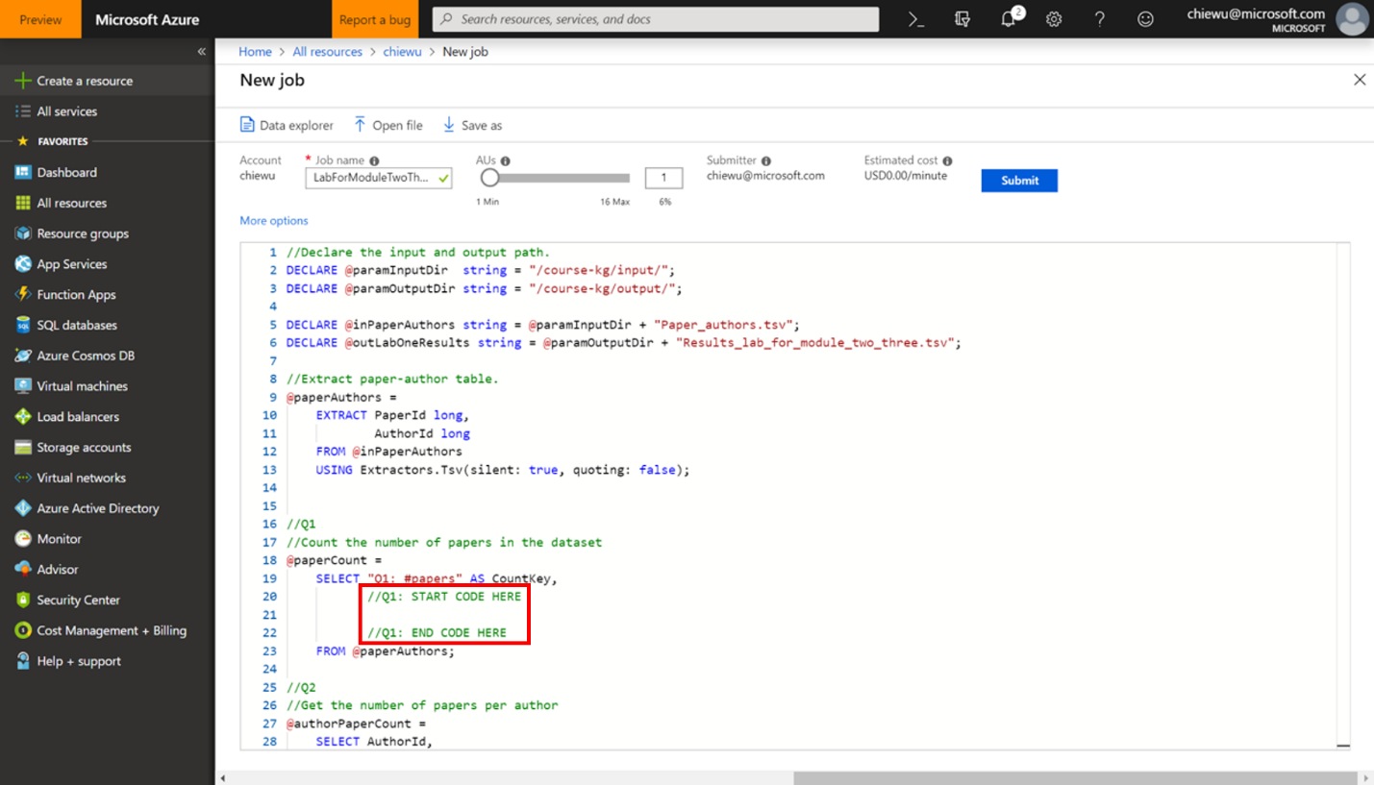

* 1. For the first question Q1 in the first lab, the correct code is filled below.

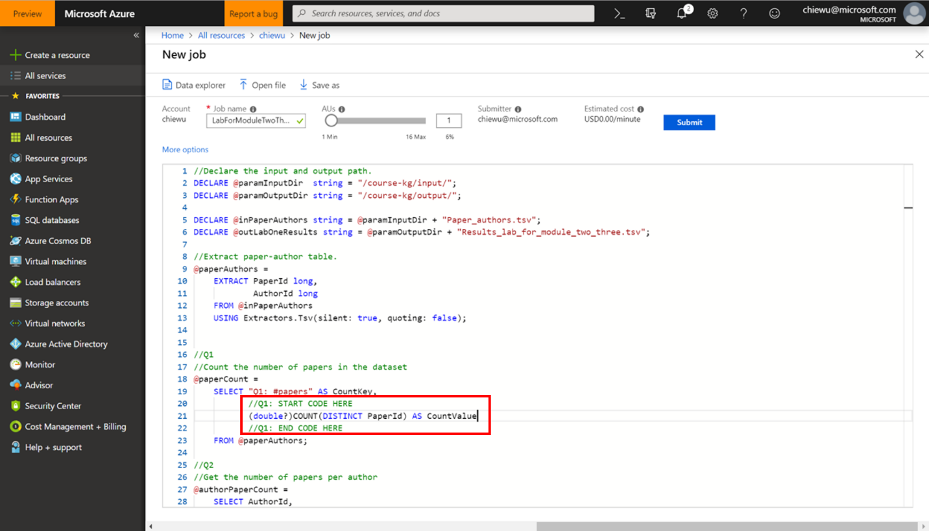

* 1. After completing all the missing code for the lab, click **Submit** to submit the job. The computing cost will be covered by [$200 Azure credit](https://azure.microsoft.com/en-us/free/) that you received when you registered for the Azure free account.

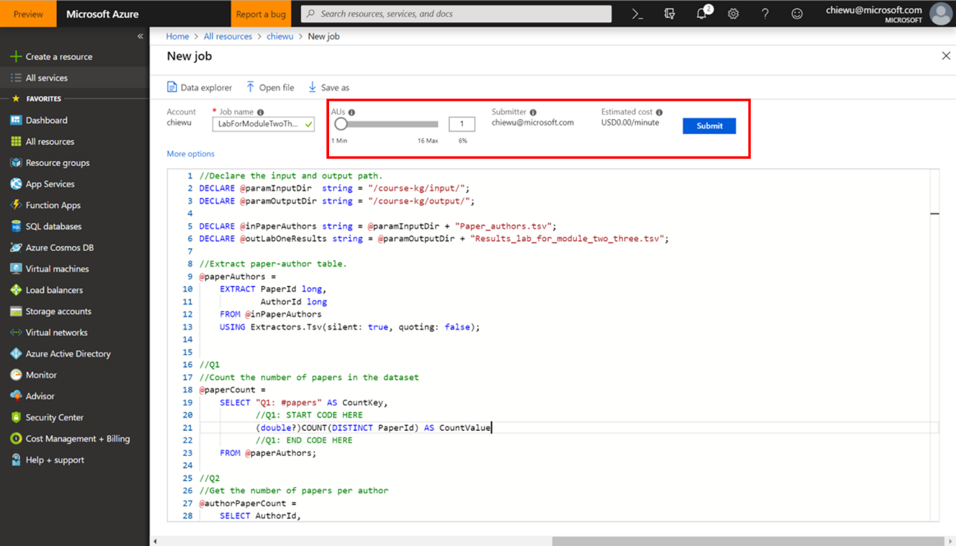

* 1. After running the script successfully, the results will be output to the “/course-kg/output/” folder.